**Raymond You and Elizabeth Cho**

**CS 3200 - Database Design**

**Final Project - Progress Report**

**1. Please use the project proposal as your starting point for the progress report. This progress report is an evolution of the project proposal. Please update your project proposal to answer all questions posed in the proposal’s feedback. (1 point)**

A top level description of the project. Briefly describe the data domain and the functionality you plan to provide for the user (MODIFIED)

Our proposed project is an application through which users can create and reference their favorite outfits. The user will be able to add new articles of clothing, create new outfits, delete clothing, delete outfits. This application will save users the time and effort required to choose a new outfit every day.

The initial page will be a sign-up/login screen where the user can sign up and login to the application. Once logged in, the user can add outfits where each outfit can contain a top, bottom, hat, shoes, or outerwear. The user can create, remove, update, or delete these outfits. Users all have a view of their own, personalized outfits. If the user loses a clothing article in an outfit or removes a hat from a outfit, that field should be set to NULL since it wouldn’t make sense to delete the entire outfit as a result. Also, the user can view all the clothing articles and outfits currently in the user account. Finally, once the user is done with all of his actions, he can exit or log out of the application.

We will initially have a table for each user (User) which will contain all the pertinent information for each user such as first name, last name, number of outfits, age, and gender. The primary key of that table will be the UserID. Next, we will a table for each outfit created (Outfit) that is identified by the primary key OutfitID. It will also contain the number of items in the outfit, a description of the outfit, and a UserID to identify which user created this outfit. Next, we will have a table to represent each individual clothing article (OutfitArticle) in the database. In this table, there will be columns for the type of article, size, color, brand, material, price, article description, and date purchased. There will also be a table for the article types (ArticleType) with the typeID as the primary key and other columns such as Type and TypeDescription. An example of a row in this table would be: TypeID = 1, Type = Top, TypeDescription = A short-sleeved T-Shirt. Finally, there will be an association table to represent which clothing article is in which outfit (OutfitToArtcle) with primary keys: OutfitID and ArticleID. This will allow for easy search queries to see what each outfit has and because a clothing article can be in multiple outfits.

The tables are here below:

User

UserID (INT) (Primary Key)

FName (VARCHAR(45))

LName (VARCHAR(45))

NumOutfits (INT)

Age (INT)

Gender (VARCHAR(45))

Outfit

OutfitID (INT) (Primary Key)

NumItems (INT)

UserID (INT) (Foreign Key)

OutfitDescription (VARCHAR(45))

OutfitArticle

ArticleID (INT) (Primary Key)

ArticleType (INT) (Foreign Key)

Size (VARCHAR(45))

Color (VARCHAR(45))

Brand (VARCHAR(45))

Material (VARCHAR(45))

Price (INT)  
ArticleDescription (VARCHAR(45))

DatePurchased (DATE)

OutfitToArticle

OutfitID (INT) (PK, FK)

ArticleID (INT) (PK, FK)

ArticleType

TypeID (INT) (PK)

Type (VARCHAR(45))

TypeDescription (VARCHAR(45))

**2. An UML diagram of the database which you will be using for the project. This diagram should contain attributes, entities, relationships, multiplicity, and primary keys. You can use any diagramming tool you prefer. One that is freely available is https://creately.com/ . You should plan on using this image during your class project presentation as well as in your final project write-up (where it will be graded more strictly and worth more points). (3 Points MySQL , 4 Points NoSQL).**

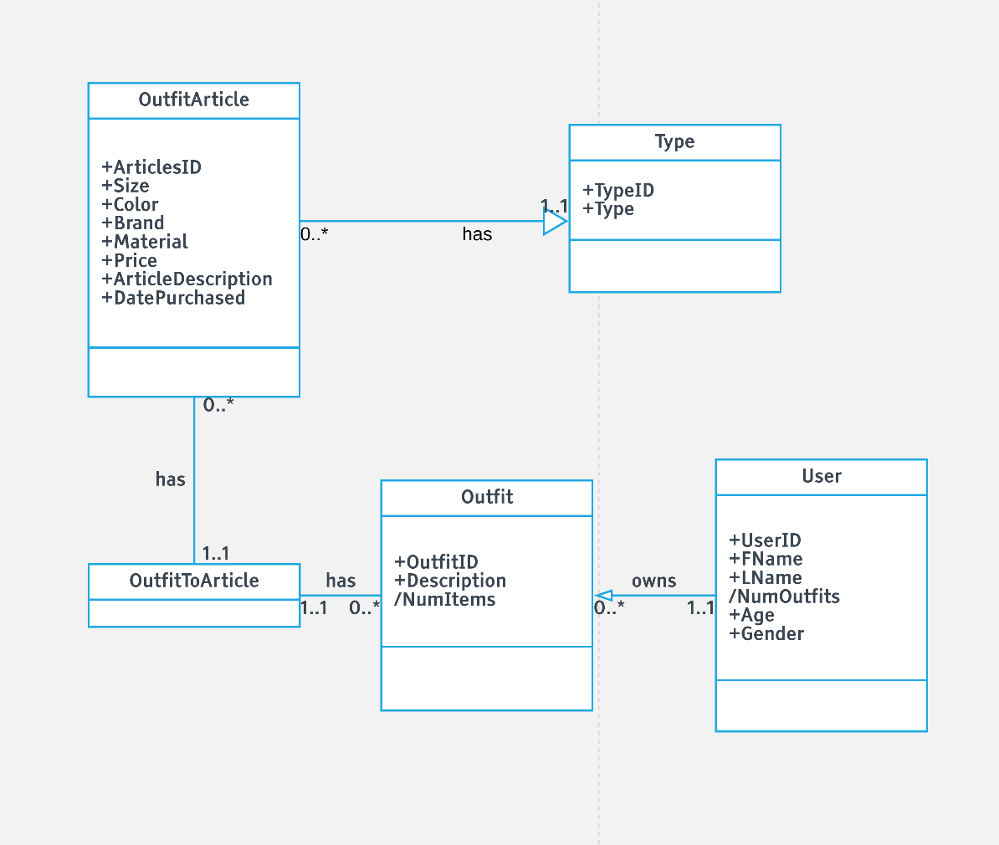

**3. An EER diagram converting the UML diagram to a relational schema. Please use the MySQL modeling tool. If you are using NoSQL you do not need to submit this. ( 1 point MySQL)**

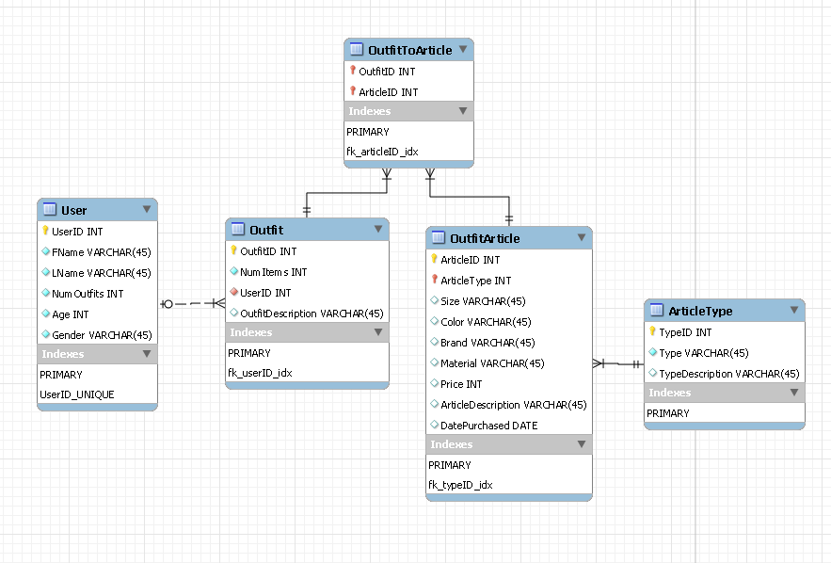

**4. A brief step by step user interaction of your application. The description should list the steps a user would require to perform in order to use your application. A flow chart is sufficient. For students who know what an activity diagram is, please include an activity diagram INSTEAD OF the steps mentioned above. (3 Points)**

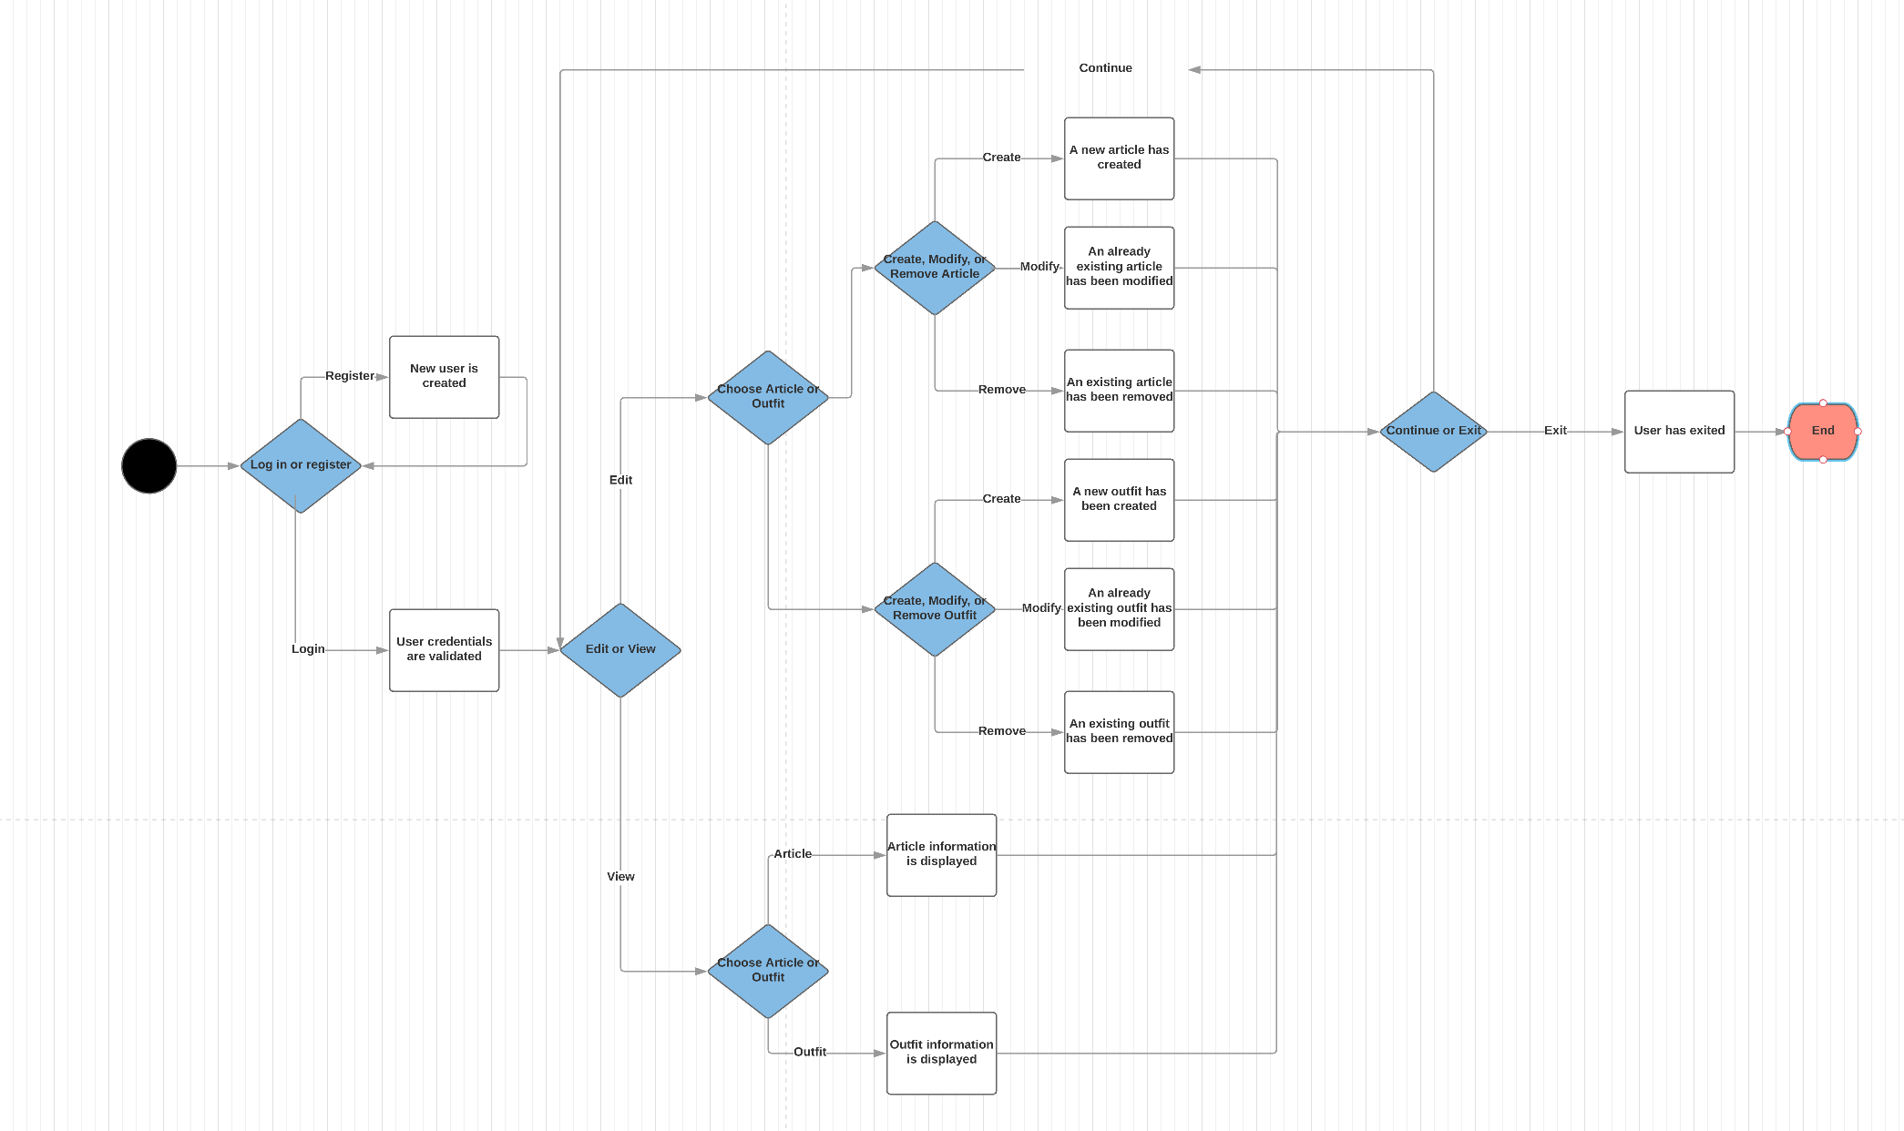

**5. A final decision on the technology used to create the project. Please include details such as toolkits, libraries, backend languages, front end languages (name and version), web technologies and database connectivity. Please make sure that you include the specifications in a separate section titled Technical Specifications within the progress report. If you included the specifications within your original proposal reiterate them here (cut and paste of the text is fine). (2 points)**

**Technical Specifications**

We will be using the follow below:

Python (3.64)

Flask (0.12.2)

MySQL (5.7.21)

HTML  
CSS  
JavaScript

JQuery (3.3.1)